San Diego Inner City Junior Golf Foundation Incorporated.
(Membership Application)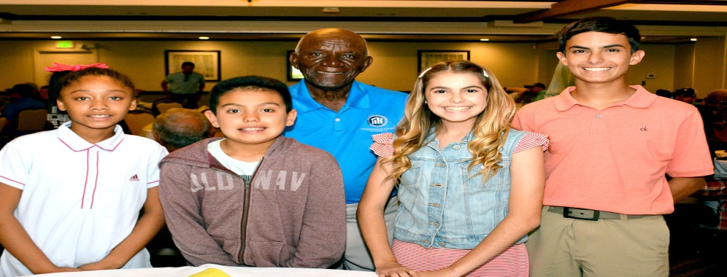
Name ______________________________________________.
Birthdate:__________________ Gender: Male_______ Female______.
Address:___________________________________________________.
City:___________________ State:__________ Zip Code:____________.
Daytime Phone: _________________ Cell Phone:__________________.
Why do you want to learn the game of Golf?_____________________.
Who is your favorite Golfer?___________________________________.
Questions:_________________________________________________.
Release of Liabilities:____________________ (y) (N)
Parent(s) Signature:__________________________________________.
5276 Churchward St. San Diego CA 92114 Phone (619) 251.0171
Web-address: www.SanDiegoJuniorGolf.com

